Math- Percent of Change in the Wolf Population at YNP

Grade – Level: 6th and 7th grade

Learning Objectives:
Students will
- Calculate the percent of change a given population to analyze a current issue.

Prerequisite knowledge:
How do read a bar graph, a working knowledge of percent and percent of change

Lesson Overview: In this lesson, the student will look at the percent of change in the population of the grey wolf at Yellowstone National Park (YNP). Initially the students are given data on just the wolf from when it was reintroduced into YNP.

Materials Needed: Internet access, pencil, paper, calculator

Instructional Plan
It might be beneficial to start the class with a review of how to calculate the Percent of Change. Depending on your students you might want to refer this to growth rate/decline.

For example:
[City X] has a population of 1,800,000 in 1997 and a population of 1,500,000 in 2012. What is the percent of change?

Springboard the class off with the following video:
http://www.pbs.org/wnet/nature/episodes/the-wolf-that-changed-america/video-wolf-expert-doug-smith-on-the-yellowstone-wolf-project/4332/

Inform the students that they will be analyzing wolf population data. Pass out ‘Who’s Afraid of the Big Bad Wolf” worksheet. You can have the students work in pairs or individuals.

If possible have the links listed on the worksheet posted on the class website so they are easy for the students to get to.

Name: Class: Date:

Who’s afraid of the Big Bad Wolf?

Answer the following questions, given the following graph below:
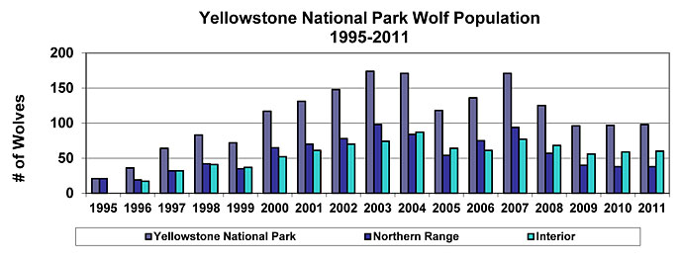
Source: http://www.nps.gov/yell/naturescience/wolves.htm

- Write three statements about the wolf population from the above graph of the various regions.

- What is the percent of change of wolf population from 1995 to 2011 in Yellowstone National Park? The Northern Range? The Interior?
- Is the percent change from 1995 to 2011 the greatest percent change (increase or decrease) for the wolf population in Yellowstone National Park? Explain. (HINT: you might have to make numerous calculations)
- What do you think contributed to the various rises and falls of the wolf population from1995 to 2011? Then share with your partner.
- Refer to the following links to read about wolf reintroduction into Yellowstone Park.
National Park Service: Wolves of Yellowstone:
http://www.nps.gov/yell/naturescience/wolves.htm
PBS Special on the Yellowstone Wolf:
- http://www.pbs.org/wnet/nature/episodes/in-the-valley-of-the-wolves/introduction/212/
- http://www.pbs.org/wnet/nature/episodes/in-the-valley-of-the-wolves/reintroduction-of-the-wolves/213/
PBS fact sheet on the grey wolf:
http://www.pbs.org/wnet/nature/episodes/river-of-no-return/gray-wolf-fact-sheet/7659/

- What animal population(s) have been affected by the introduction of the wolves? Why?
- What is the most interesting fact that you found about the gray wolf? Share with your partner.

Possible Extensions or Assessment Options
- Have the student(s) research various animal populations in their current state (or region) over a significant period. Have them determine the percent increase/decrease of the populations and research possible causes and effects.
- Have the student research the human growth rate in their area http://www.indexmundi.com/facts/united-states/quick-facts/all-states/population-growth#map
- Look at various World Populations:
http://www.prb.org/Educators/LessonPlans/2012/WorldPopulationDataSheet.aspx

