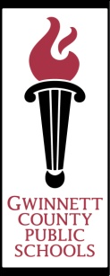Academic Knowledge & Skills

Instructional Plan

***Kari Parlier, Ed.S.and Michael Parlier, Ed.S.***

**Unit Name**

|  |
| --- |
| Volcanoes and Super Volcanoes-Extension to Rocks and Minerals Unit |

**Lesson Name Time Needed (Hours/Days)**

|  |  |
| --- | --- |
| Window Notes with Informational Writing | 45-60 min. block/3-4 weeks |

**Grade**  **Subject**  **Course Topic-Strand**

|  |  |  |  |
| --- | --- | --- | --- |
| 3 | Reading, Writing and Science | n/a | Rocks and minerals, reading comp., research, informational writing, volcanoes, super volcanoes, geothermal features |

**AKS # Description**

|  |  |
| --- | --- |
| 3SC_A2006-6 | Communicate scientific ideas and activities clearly |
| 3SC_A2006-7 | Questions scientific claims and arguments effectively |
| 3SC_B2006-8 | investigate the physical attributes of rocks and soils |
| 3LA_E2009_67 | Write and publish in a variety of genres, including content are writing… |
| 3LA_G2009_85 | Include relevant examples, facts, anecdotes and supporting details |
| 3LA_G2009_86 | Use organizational structures for conveying information (chronological order, cause and effect, similarities and differences, questions and answers) |
| 3LA_G2009_87 | Use a variety of resources to research and share information on a topic |

**Materials/Links/Text References**

|  |
| --- |
|  |
| Stories printed from abcteach.com, Scholastic News issues, videos on volcanoes-Bill Nye and other resources, images of volcano sites (Mt. Vesuvius, Mt. St. Helens, the Ring of Fire) from yahoo.com, computer programs BrainPop, BrainPop Jr. and Powerkids Science Series, information from Wikipedia for pyroclastic flows and super volcanoes stories, personal pictures of Yellowstone National Park-caldera, geothermal features, etc.  **Stories and rubric used attached to this document.** |

**Essential Questions**

*What should students know when unit or lesson is completed?*

|  |
| --- |
| What is a volcano?  Explain the ways volcanoes are formed.  Describe the different types of volcanoes.  What are tectonic plates? Explain their significance in the forming of volcanoes.  What is a super volcano? How is it different from a “regular” volcano?  Where is the biggest super volcano in the world located?  Explain geothermal features.  How are volcanoes useful?  Why do we need relevant facts, examples and supporting details in Informational Writing pieces?  What is the purpose of Informational Writing? Explain the authors’ responsibilities when writing an informational piece. |

**Essential Vocabulary** *(note academic language for ELL students)*

|  |
| --- |
| examples, facts, supporting details, volcanoes, super volcanoes, sediment, geothermal, cindercone, composite, shield, lava, vent, eruption, pyroclastic flow, caldera, Ring of Fire, minerals, rocks, captions, subheadings, reaction |

**Required Background Knowledge for Students**

|  |
| --- |
| *Attach a file or insert an existing resource here:* |
| Students need to have a good knowledge base of rocks and minerals. They also need to have a good understanding of Writing Workshop and all that is expected of them as writers when they are drafting. They need to understand the roles of Literature Circles and how each Literature Circle group functions productively. Students need to know how to properly work cooperatively with one another in their Literature Circle groups. Students need to know how to correctly read and understand non-fiction/informational text. Students need to understand and apply reading strategies. The GCPS Instructional Calendar plans the third grade science unit on rocks and minerals for the middle of the year, so the students are well-versed in the procedures, roles, and expectations of Writing Workshop, Literature Circles, and reading for meaning with non-fiction/information text. |

**Quality + Teaching Strategies**

|  |  |  |  |
| --- | --- | --- | --- |
| **X** | Assessment:  Frequently assess students and give specific feedback | X | Background Knowledge:  Teacher builds connections & students learn to build their own |
| **X** | Comparison & Contrast:  Students compare/contrast knowledge, concepts, content | X | Collaboration:  Provide collaborative learning opportunities |
| **X** | Literacy:  Skills taught and students use effectively and often | X | Modeling & Practice:  Multiple opportunities for guided & independent practice |
| **x** | Non-Verbal Representation:  Teacher/students use a variety to illustrate content |  | Problem Solving:  Inquiry based learning strategies in all subjects |
| **X** | Questioning:  Use and teach questioning and cuing/prompting techniques |  | Student Goal Setting:  Students are taught and practice academic goal setting |
| **X** | Summarizing:  Explicitly taught and student summarize in multiple ways | x | Vocabulary:  Content related vocabulary taught and used correctly by students |
| **X** | Technology:  Students use technology to access content, to collaborate |  | **Check All That Apply** |

**Instructional Activities**

|  |
| --- |
|  |
| *Whole group work – read and discuss all abcteach.com stories that will be copied for each child as teacher guides whole group in how to highlight new, important information that will be used on final volcano project (each story will take 1-2 days to complete-some stories will be highlighted by students without teacher direction – after sufficient practice as a whole group). Students reread stories independently to review and answer attached questions;  *”Turn and Talk” with a partner about parts of non-fiction text they notice and why those parts are useful and important (subheadings, important vocabulary to use in their own projects, etc.);  *Work in small Literature Circle groups to work through additional stories/materials about volcanoes (books checked out from the library, books brought in by other students, etc.) to highlight information to be included in final project;  *Watch videos on volcanoes as a whole group, stopping intermittently to take notes on new information to include in project;  *Work in Literature Circle Groups to organize project – decide on subheadings and/or categories, organize information on volcano shapebook pages (prewriting);  * Work in Literature Circles to make volcano project (after many whole group discussions on exercising creativity with their projects, using material that will teach others something new, making sure the project is well done and organized, etc.);  * Work in computer labs to take notes from programs that offer information about volcanoes, tectonic plates |

**Assessment Strategies**

|  |
| --- |
|  |
| Students are assessed during Literature Circles with the Rubric I have pasted to this document. Because the students’ writing pieces will come directly from information highlighted and gathered from stories used in class, I will be able to use the “Comprehension” and “Reading is Thinking” sections of the rubric to grade their writing pieces as well as their reading comprehension on pieces done independently. |

**Differentiation**

*Scaffolds/Language/ESOL Interventions/Extensions/Enrichment/Other*

|  |
| --- |
| Students’ Literature Circle groups are homogeneous groups according to their ability level. Higher groups work with books that are higher reading and comprehension level. The teacher will need to circulate around the room to monitor group work and facilitate student learning. Students working below grade level, or who need further interventions because of ESOL or RTI will need further assistance from the teacher while working in their Literature Circle groups. |

**Summarizing Strategies**

|  |
| --- |
| Additional Mini-lessons and group study will be on the following topics:  -Discerning between information that is just interesting or new, important information that teaches something in non-fiction pieces;  - Note-taking;  -Summarizing information on culminating volcano project; |

**Copyright/Citations**

|  |
| --- |
| Window Notes strategy from The Strategic Teacher-Selecting the Right Research-Based Strategy for Every Lesson by Harvey F. Silver, Richard W. Strong and Matthew J. Perini |

|  |  |  |  |  |
| --- | --- | --- | --- | --- |
| CATEGORY | 4 | 3 | 2 | 1 |
| Respects Others | Student listens quietly, does not interrupt, and stays in assigned place without distracting fidgeting. | Student listens quietly and does not interrupt. Moves a couple of times, but does not distract others. | Student interrupts once or twice, but comments are relevant. Stays in assigned place without distracting movements. | Student interrupts often by whispering, making comments or noises that distract others OR moves around in ways that distract others. |
| Comprehension | Student seems to understand entire story and accurately answers 3 questions related to the story. | Student seems to understand most of the story and accurately answers 2 questions related to the story. | Student understands some parts of the story and accurately answers 1 question related to the story. | Student has trouble understanding or remembering most parts of the story. |
| Participates Willingly | Student routinely volunteers answers to questions and willingly tries to answer questions s/he is asked. | Student volunteers once or twice and willingly tries to all questions s/he is asked. | Student does not volunteer answers, but willing tries to answer questions s/he is asked. | Student does not willingly participate. |
| Reading is Thinking  ( Roles completed with thought) | Student completes all of their assigned roles with responses that demonstrate evidence of evaluative thinking and creativity. | Student completes all of their assigned roles with responses that demonstrate evidence of application and analysis of key concepts and themes. | Student completes assigned roles with responses that demonstrate evidence of limited knowledge and understanding. | Student completes assigned roles with little to no evidence of knowledge, understanding or memory of what has been discussed or taught. (Random thoughts or answers) |
| Follows Along | Student is on the correct page and is actively reading along (eyes move along the lines) or finger is following words being read aloud by others. | Student is on the correct page and usually appears to be actively reading, but looks at the reader or the pictures occasionally. Can find place easily when called upon to read. | Student is on the correct page and seems to read along occasionally. May have a little trouble finding place when called upon to read. | Student is on the wrong page OR is clearly reading ahead or behind the person who is reading aloud. |

©2009-2011 abcteach.com

**VOLCANOES**



Earth has several layers. The hard outer layer is the *crust*. The crust is the part of Earth that we live and walk on. The inside of Earth is the *core*. The outer part of the core is a very hot liquid metal.

Between the outer core and the crust is a layer called the *mantle*. The mantle is *molten rock* –made liquid (melted) by heat. The molten material is called *magma*.

There are cracks in Earth’s crust. There are places where the crust is thin. Sometimes the hot magma from the mantle bursts through the crust in these places. When the magma bursts through, it is called *lava*. Ash, steam, and rocks also escape through the opening. The opening is a *volcano*. When lava escapes from a volcano, the volcano is *erupting*.

A volcano gives some hints before it erupts. Steam, gas, and little spurts of lava show that the volcano is *active*. Some volcanoes do not erupt for many years. These volcanoes are *dormant.* Some volcanoes will not erupt again. These volcanoes are *extinct*.

Volcanoes have different shapes. They can be tall like mountains or flat like shields. They have different eruption styles and materials. They can have different locations. They can be on the ground, under the water... even on other planets!

Volcano eruptions can be dangerous. The gases that are released during an eruption can be poisonous. Eruptions may change the way the land looks. Eruptions may destroy trees, homes, and other structures.

A volcano even changes itself when it erupts. It may get bigger as the lava, cinder, and ash are added to its sides. It may have a crater at the top. It may collapse and leave a bowl-shaped hole in the ground.

*Geologists* are scientists who study rocks and Earth. A scientist who studies volcanoes is a *volcanologist.* Volcanologists study the different types of volcanoes. They use what they learn to help people predict volcano eruptions.

**ANSWER THE QUESTIONS ABOUT *VOLCANOES*:**

**1.** The layers of Earth, in order from outer to inner, are:

a. crust, core, mantle

b. crust, inner core, mantle, outer core

c. crust, mantle, outer core, inner core

d. crust, outer core, mantle, inner core

**2.** Which of the following things could be described as *molten*?

a. pudding, before it has hardened

b. ice cream, after it has melted

c. magma

d. all of the above

**3.** Volcanoes erupt in places…

a. Where Earth’s crust is thin

b. Where Earth’s crust is cracked

c. Where they are unexpected

d. Both a and b

**4.** When hot liquid comes out of a volcano, this is

a. an eruption

b. an explosion

c. dormant

d. on another planet

**5.** A volcano eruption is

a. dangerous for plants and animals

b. dangerous only for animals

c. dangerous only for people

d. dangerous only for plants

**6.** Volcano eruptions are dangerous because of

a. the lava, which is bad for plants.

b. heat and gas.

c. bad smell and smoke.

d. nothing. They are not dangerous.

**7.** Where can you find volcanoes?

a. on the land

b. in the sea

c. on other planets

d. all of the above

Reading Comprehension/ Science/ Geography

**Write complete sentences to answer the questions below.**

1. Imagine watching a volcanic eruption. Describe.

______________________________________________________ ________________________________________________________________________________________________________________________________________________________________________________________________________________________

2. Tell how this article reminds you of an experience you have had (yourself or with your family or friends).

______________________________________________________ ________________________________________________________________________________________________________________________________________________________________________________________________________________________

3. After reading the story what do you think is meant by *magma*?

______________________________________________________ ____________________________________________________________________________________________________________

4. What did you learn about volcanoes that you did not know? How will you use that new information?

______________________________________________________ ________________________________________________________________________________________________________________________________________________________________________________________________________________________

**ANSWERS TO *VOLCANOES***

Multiple-choice

1. c

2. d

3. d

4. a

5. a

6. b

7. d

Short-answer

1. (Answers may vary, accept reasonable answers.)

2. (Answers may vary, accept reasonable answers.)

3. Magma = hot, molten (liquid) rock

4. (Answers may vary, accept reasonable answers.)

Volcanoes

Name: __________________________________ Date: ________________________

©2004abcteach.com

**Fire from the Earth ~ Volcanoes!**

You’ve probably seen a picture of a volcano in a book or on television, but do you

know what a volcano really is, or how one is formed? A volcano is a vent, or opening, in Earth’s surface through which *magma* (melted rock) flows. Deep down in the Earth, the

temperature is so high that rocks actually melt to form magma. The pressure deep in the Earth is also very high, and it is this pressure that pushes the magma and gases up to the Earth’s surface.

If you cut the Earth in half, you would see four different layers. At the very center

of the Earth is the *inner core*. The inner core is about 750 miles thick. Even though

scientists cannot measure the temperature, it is estimated to be about 10,000 degrees!

The inner core is made up of liquid metals, but the pressure is so high that the metals

cannot move around and are forced to stay still, just like a solid metal ball. Around the

inner core is the *outer core*, which is about 1,400 miles thick. The outer core is also

made up of melted metals, but the outer core is not forced to stay still. Around the outer

core is the Earth’s *mantle*. The mantle is about 1,800 miles thick, and it is here that

most of the rock melts to form magma. Movement of magma in the mantle causes the

Earth’s plates to move. The outermost layer of the Earth is just like the peel of an

orange, and is called the crust. This is the part that we live on. The crust isn’t solid, but

is made up of several plates that float on the magma in the mantle. The crust is about

25 miles thick underneath land, and about 4 miles thick under the oceans. The Earth’s

plates are always moving, and this helps volcanoes to form.

One of the places where volcanoes form is where two plates meet. Volcanoes

form either where two plates are bumping into each other, or where two plates are

moving away from each other. Most of the volcanoes that are formed because of plates

moving away from each other are formed in the middle of the ocean. This type of

volcanic activity is called *spreading center volcanism*. When two plates meet and bump

into each other, one plate moves down below the other plate. The place where one

plate moves below another plate is called the *subduction zone*, and any volcanic activity

in this area is called *subduction zone volcanism*. The place on Earth that has the most

volcanic activity is called the *Ring of Fire*. The ring of fire is a subduction zone that runs

around the Pacific Ocean. This is how Mt. St. Helens was formed.

Another place that volcanoes can form is right in the middle of a plate.

Sometimes because of the way that magma moves around in the mantle, pressure and

magma can build up in one specific place, and when enough pressure has built up

magma erupts up through the crust. These places are called *hotspots* and volcanic

activity due to hotspots is called *intra-plate (hotspot) volcanism*. Hotspots always remain

in the same place, but the plate above them continues to move. When this happens,

and the hotspot occurs in the ocean, chains of islands can form. This is how the

Hawaiian Islands were formed!

When volcanoes erupt, magma flows out of the vent and downwards along the

ground. Once magma has erupted, it is called *lava*. Slowly the lava cools into hard

volcanic rock, and over time lava builds up on the ground to form mountains. The

Hawaiian Islands are the tips of giant underwater mountains!

Volcanoes

Name: __________________________________ Date: ________________________

©2004abcteach.com

Questions on **Volcanoes**

1. What is a volcano?

________________________________________________________________

________________________________________________________________

2. How many layers does the Earth have? What are they called?

________________________________________________________________

________________________________________________________________

3. Describe the mantle.

________________________________________________________________

________________________________________________________________

_______________________________________________________________

4. Where does spreading center volcanism occur?

________________________________________________________________

________________________________________________________________

________________________________________________________________

5. What is the Ring of Fire?

________________________________________________________________

_______________________________________________________________

6. What is the difference between subduction zone volcanism and spreading center

volcanism?

________________________________________________________________

________________________________________________________________

7. What is it called when volcanoes form because of hotspots?

________________________________________________________________

________________________________________________________________

8. Describe how the Hawaiian Islands were formed.

________________________________________________________________

________________________________________________________________

9. What is the difference between magma and lava?

________________________________________________________________

________________________________________________________________

Volcanoes

©2004abcteach.com

**Answers to Volcanoes**

1. A volcano is an opening or vent in the Earth’s surface through which magma

flows.

2. The Earth has 4 layers: inner core, outer core, mantle and crust.

3. The mantle is the thickest layer of the Earth. It is just below the crust and on top

of the outer core. The mantle is made up of melted rock or magma.

4. Spreading center volcanism occurs when two plates are moving away from each

other. Usually this occurs in the middle of an ocean.

5. The Ring of Fire is the area around the Pacific Ocean where the most volcanic

activity occurs.

6. Subduction zone volcanism occurs when two plates meet and one of the plates

moves below the other. Spreading center volcanism occurs when two plates are

moving apart.

7. When volcanoes form because of hotspots it’s called intra-plate or hotspot

volcanism.

8. The Hawaiian Islands were formed because of intra-plate volcanism. The hotspot

remained in the same spot but the plate above the hotspot kept moving. As the

plate moved new volcanoes were formed and eventually formed the island chain

known as the Hawaiian Islands.

9. Magma and lava are almost the same, except that magma is below ground and

lava is magma that has erupted.

Reading Comprehension/Volcanoes

©2004-2009 abcteach.com

**VOLCANO TYPES**

Just as there are different ways that a volcano can form, there are also different types of

volcanoes. Geologists (scientists that study rocks and Earth) divide volcanoes into four

main types: *cinder cones*, *composite volcanoes*, *shield volcanoes,* and *lava domes*.

*Cinder cones* are the simplest kind of volcano. They are built around a single *vent*, or

opening. As lava and hot gases are blown into the air, they cool and fall back down to

Earth as *cinders*. These cinders gather around the vent and form a cone with a crater in

the middle. Most cinder cones do not get taller than about 1000 feet above the rest of

the landscape. Cinder cones are often found on the sides of composite volcanoes,

shield volcanoes, and calderas.

*Composite volcanoes*, sometimes called *stratovolcanoes*, form some of the most

beautiful and well-known mountains in the world. Among the most famous composite

volcanoes are Mount Fuji in Japan, Mount Cotopaxi in Ecuador and Mount St. Helens

and Mount Rainier in Washington. Like cinder cones, most composite volcanoes have a

crater at the top, with a central vent or a cluster of vents. When lava erupts from the

vent, it flows down the side of the volcano through breaks in the crater or through cracks

in the side of the volcano. The volcano gets bigger as lava, cinder, and ash are added

to the slopes. Sometimes large amounts of lava can erupt very quickly. When this

happens, empty spaces in the ground below the volcano form and the volcano can no

longer be supported. Without support, the volcano collapses and forms a deep bowlshaped

hole in the ground, called a *caldera*. Crater Lake in the United States is a

caldera that has filled with water. After the collapse of the volcano, before the caldera

filled with water, a final bit of volcanic activity produced a cinder cone on the side of the

caldera. This cinder cone is now Wizard Island in Crater Lake.

*Shield volcanoes* are different from the first two types of volcanoes, in that they are built

almost entirely from lava flow. Lava flows out of the central vent or group of vents and

flows downward across the ground. As the volcano grows, it begins to look like a

warrior’s shield, which is how this type of volcano got its name. After thousands of lava

flows, the volcano can become very big. In fact, some of the largest volcanoes in the

world are shield volcanoes. There are some shield volcanoes in northern California that

have a base of 3-4 miles and a height of 1500 to 2000 feet. The biggest shield volcano,

in fact the world’s biggest active volcano, is Mauna Loa in Hawaii. The floor of the ocean

is more than 15,000 feet below the base of the island, and the top of Mauna Loa is

another 13,677 feet above sea level. That means that the entire volcano is over 28,000

feet!

*Lava domes* usually form in the crater or on the sides of large composite volcanoes.

The domes form when very thick lava is ejected from a vent or crack. The lava is too

thick to flow very far, and just begins to harden around the vent. Lava domes grow from

the inside. The outer layer of lava cools and hardens, but as more lava is ejected from

the vent, the outer layers crack and crumble down the sides of the dome. Three of the

most active composite volcanoes in the Cascade Range in the United States – Mount

St. Helens, Mount Shasta, and Glacier Peak – all have lava domes at their summits (the

top of the volcano).

Reading Comprehension/Volcanoes

©2004-2009 abcteach.com

Name _____________________________________ Date _______________________

**QUESTIONS ABOUT *VOLCANO TYPES***

1. What are the four main types of volcanoes?

_________________________________________________________________________

_________________________________________________________________________

2. How do cinder cones form?

_________________________________________________________________________

_________________________________________________________________________

_________________________________________________________________________

3. What type of volcano is Mount St. Helens an example of?

_________________________________________________________________________

4. What is a caldera?

_________________________________________________________________________

_________________________________________________________________________

5. How do shield volcanoes form?

_________________________________________________________________________

_________________________________________________________________________

_________________________________________________________________________

6. What forms when the lava ejected is too thick to flow?

_________________________________________________________________________

7. Research one of the following volcanoes and give a brief description of it. Include

location, type, activity, and any special features.

- Mount St. Helens

- Mount Fuji

- Paricutin

- Mount Vesuvius

- Mount Loa

- Krakatau

_________________________________________________________________________

_________________________________________________________________________

_________________________________________________________________________

_________________________________________________________________________

_________________________________________________________________________

_________________________________________________________________________

Reading Comprehension/Volcanoes

©2004-2009 abcteach.com

**ANSWERS TO *VOLCANO TYPES***

The four main types of volcanoes are: cinder cones, composite volcanoes, shield

volcanoes and lava domes.

1. Cinder cones form when hot lava and gases are blown into the air, cool and fall

back to Earth as cinders. The cinders gather around the vent and form a cone

with a crater on top.

2. Mount St. Helens is an example of a composite volcano.

3. A caldera is the bowl-shaped hole left in the ground after a volcano has

collapsed. Crater Lake is an example of a caldera.

4. Shield volcanoes form almost entirely because of lava flows. Lava flows out of a

central vent or collection of vents and out over the ground. The lava cools in thin

sheets and after thousands of lava flows the volcano can grow quite large.

5. A lava dome forms when the lava ejected is too thick to flow.

6. Individual research activity.

**Pyroclastic Flows**

Pyroclastic flows traveling down the side of a volcano at hurricane speeds are awe inspiring sights that occur during large volcanic eruptions. At the beginning stages of a large eruption a column forms over the vent of the volcano. The eruption column blasts superheated ash and rocks over 15 miles into the atmosphere.

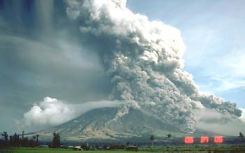

A ground-hugging avalanche of hot ash, pumice, and rock fragments forms when part of the eruption column collapses and begins flowing down the side of the mountain. The flow travels down the slope of the volcano at speeds up to 150 miles per hour.

The temperature inside the flow of hot gases and rock can reach 1500 degrees Fahrenheit. These "stone winds" traveling at hurricane speeds kill or destroy everything in their path. The flows usually follow the curvature of the land to the valleys below the mountain. Sometimes a pyroclastic surge will jump ridges and flow down nearby valleys spreading the destruction into new areas.

Island volcanoes sometimes create these flows that travel across the surface of the ocean to nearby islands. During the eruption of Krakatoa in 1883 it is estimated that at least 10% of the deaths were due to falling tephra and ash flows. The superheated material traveled over 25 miles across the Sunda Straits to the island of Sumatra in Indonesia.

# Super Volcanoes

Super volcanoes is a term that has come into recent use. Supervolcano eruptions are those rare events when more than 1000 cubic kilometers (240 cubic miles) of pyroclastic material are blown out of a volcano during one eruption. These devastating events rarely occur and a supervolcano eruption has not occurred in recorded history.

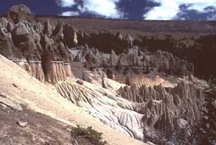

Supervolcano eruptions and megacalderas are produced by only a few volcanoes. These volcanoes are found worldwide and cover huge areas with lava and volcanic ash. They also cause long-lasting changes to the weather by lowering the Earth's atmospheric temperature and sometimes triggering mini-ice ages.

The United States has had many supervolcano eruptions in prehistoric times. The largest of these eruptions produced La Garita Caldera in Colorado. It is estimated the eruption produced 5,000 cubic kilometers of pyroclastic material including ignimbrite. The last caldera eruption at Yellowstone has been estimated to be 1000 cubic kilometers in size.

Lake Toba on North Sumatra, Indonesia produced a supervolcano eruption also before recorded history. Pyroclastic flows of hot ash and pumice covered 20,000 square kilometers of land with thick deposits of ignimbrite. Ash and welded tuff deposits near the vent are 600 meters (2000 ft) thick. The ash spread out around the Earth covering the entire subcontinent of India with 6 inches of ash.

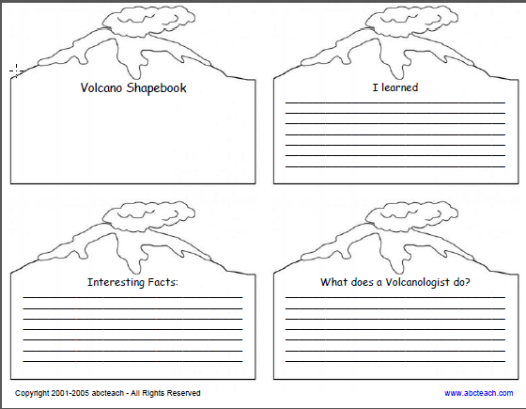

FINAL PROJECT PICS:

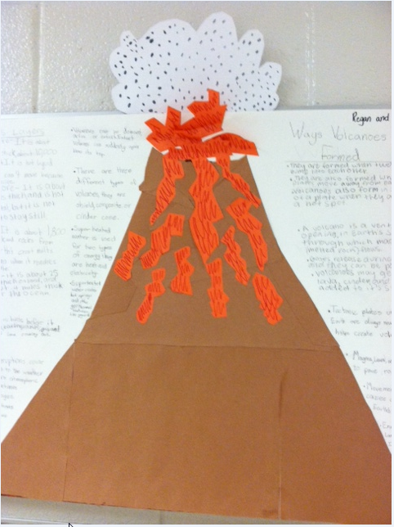

PICS CONTINUED…

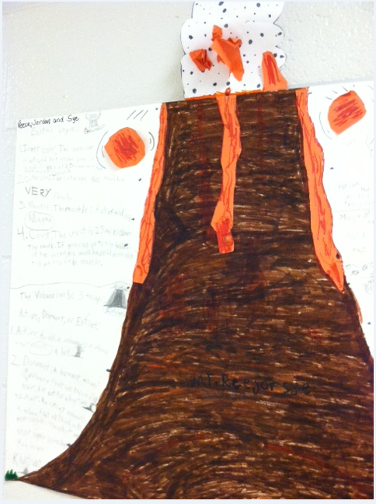

PICS CONTINUED…(last one)

